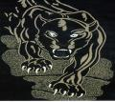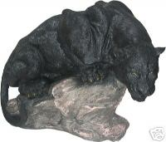
July 2012 Edition
General Information:
2012 CHRISTMAS GALA

CABHAA GEORGE D. STANYARD SCHOLARSHIP
RECIPIENT- Tommie S. Middleton

The CABHAA at its regularly scheduled meeting on August 14, 2012 awarded its $500.00 George D. Stanyard tuition scholarship to Tommie S. Middleton. She is the daughter of Penelope S. Middleton, class of 1982, and she will be attending Columbia College in Columbia, S. C. this fall majoring in English & Psychology. Tommie’s one and one-half page essay on “Why is it important for you to vote in this election” was selected from the four that were submitted. The four essays were submitted anonymously to Mr. Gerald Mackey, former English teacher at C.A. Brown, who read and critiqued them to make the final selection.
C. A. BROWN CLASS OF 1970 EFFIE M. BRYAN MEMORIAL SCHOLARSHIP RECIPIENT-NAJEE L. WASHINGTON

Our first $500.00 Class of 1970 Effie M. Bryan Memorial Scholarship was awarded to Najee Washington. Najee is the daughter of Ms. Terry Washington class of 1977. She is a rising junior at Winthrop University in Rock Hill, S. C. majoring in Athletic Training. Najee’s one and one-half page essay on “Selecting one of numerous controversies President Obama has been faced with and explain how he dealt with it” was selected from the two that were submitted. The two essays were submitted anonymously to Mrs. Joan Marshall, former English teacher at C. A. Brown High, who read and critiqued them to make the final selection.

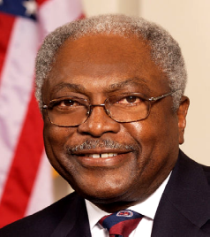
Our 2012 Christmas Gala will be held the weekend of December 21-23. The keynote speaker on Saturday December 22, 2012 is U. S. Congressman James E. Clyburn, (SC-6) House Assistant Democratic Leader, as we mark the 50th year Anniversary of the school’s opening. Festivities will be held the entire weekend of December 21-23 so mark your calendar. Along with the many activities we’re planning, we will also offer discounts and have monetary drawings. Don’t miss out on the $50.00 drawing at the Gala that will include the names of the first 50 persons who paid for the weekend events. Friday night of the Gala is “Apollo Night”. Any class or individual wishing to perform that night, please let us know. We promise you will have a good time and great fellowship.

General Information Continues:
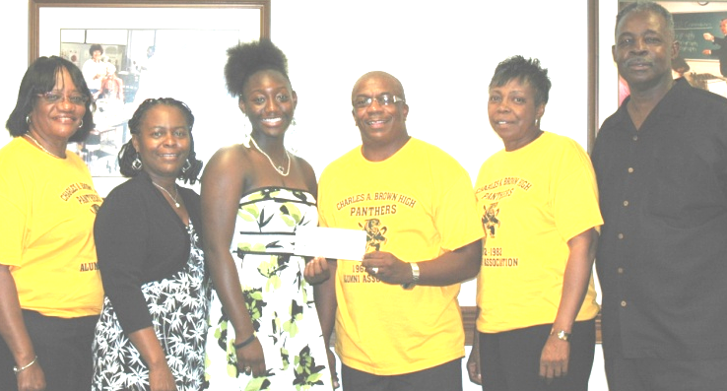
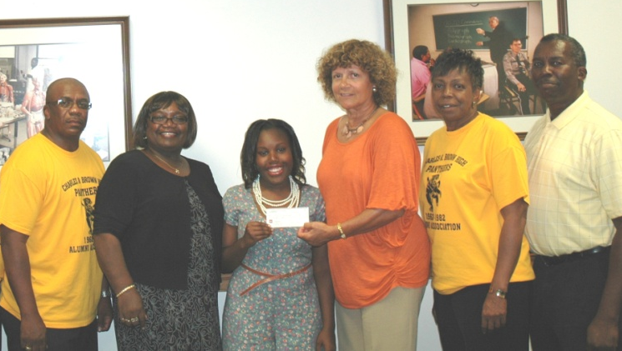

RECIPIENT- Tommie S. Middleton RECIPIENT-NAJEE L. WASHINGTON
We are still soliciting your help with the scholarship fund. You can help by making a monetary donation. All checks or money orders should be made to the CABHAA Scholarship Fund and mailed to: CABHAA Scholarship Fund; P. O. Box 532; Ladson, S. C. 29456 for George D. Stanyard Scholarship and for Effie M. Bryant Memorial Scholarship all checks or money orders should be made to C. A. Brown Class of 1970 and mailed to:
Sharon Coakley 210 Foxborough Road Goose Creek, S. C. 29445.

Don’t forget to join us on our website: www.cabhaa.org. As the Association grows, we will do our absolute best to keep you posted through e-mails, letters and by updating our web page. The annual dues for the Association are $25.00. All persons renewing their membership in 2012 will receive a beautiful reversible garment bag/clothes carrier with the school’s logo as a part of your membership package.

The audit of books for Charles A. Brown High Alumni Association, Inc. was completed during the month of May, 2012 with all findings being corrected in the thirty days time frame. This audit is for the year 2011. A copy is available for viewing by any CABHAA member.

We continue to worship together in church services quarterly. We worshipped at Shiloh AME Church during the 1st quarter with Joleitha Solomon and during the 2nd quarter we worshipped at New Tabernacle Fourth Baptist with Ruth Coleman.

Upcoming & Past Events

The Association is now taking orders for t-shirts. If you’re interested in purchasing a shirt, place your order in advance to avoid not having your size. We will have shirts for sale at the Christmas Gala.
T-Shirt Back 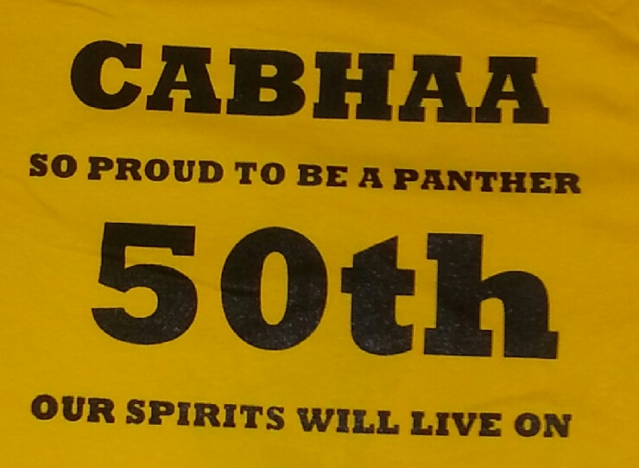 T-Shirt Front 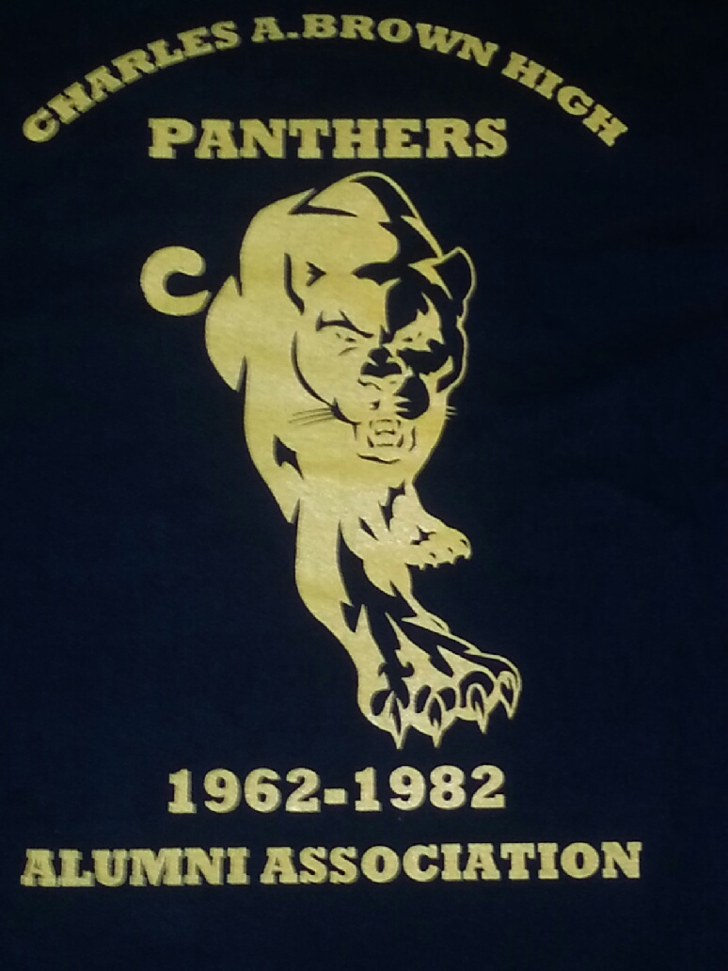

The Association held its raffle for one person to receive free admission to all the weekend events being hosted during the Christmas Gala ($80.00 value) at its August meeting. The winner of the raffle was Robert Crawford, Jr. , Charlotte, N. C., son of Robert Crawford Sr. (71).

The Class of 1967 celebrated their 15th Annual Gospel Fest on Sunday March 24, 2012 at Wesley United Methodist Church and it was a huge success with great gospel music.

Our Spring Dance was held Friday April 27, 2012 at the beautiful North Charleston Inn 2934 West Montague Avenue Charleston, SC 29418. We had a great turnout and fellowship with our classmates and lots of fun.

Congratulations

Mrs. Marjorie H. Howard celebrated her 100th birthday on August 21, 2012. A celebration was held for her on Sunday, August 19, 2012 at Wesley United Methodist Church located at 446 Meeting Street Charleston, S. C. from 3pm-6pm. When C. A. Brown High School opened in 1962, Mrs. Howard became head of its Math Department. She was Charleston County District’s first Black Teacher of the year 1975-1976. During her 43 years as a teacher she impacted the lives of many students. In 1976 Mrs. Howard retired from teaching, but she continued to touch the lives of others as a volunteer with the Charleston County Teachers Credit Union. At the age of 96 Mrs Howard still enjoyed playing Bridge and stayed fit with water aerobics. She now enjoys the television game show Jeopardy. BEST WISHES TO MRS. MARJORIE H. HOWARD!!

Zola and Dolores Simmons’ son, Gimel President of Wando High School, decided to attend Auburn after a long recruiting journey. Gimel signed a national letter of intent on National Signing Day with Auburn out of the 14 scholarship offers he had. CONGRATULATIONS GIMEL! GREAT JOB DELORES AND ZOLA!

JoeColby Thomas, daughter of Karyn T. Hart, will graduate December 2012 from Southern Weslyn University.

Joleitha Taylor Solomon (80) will graduate December 2012 from Limestone College with a B. S. in Business.

Happy Birthday goes out to the following alumni association officers: Joey Washington 1/1/12, Virgie B. Green 2/6/12, Sharon Coakley 2/10/12, and Robert Crawford 2/20/12, Ruthie Grant-Coleman 3/15/11, Joleitha Solomon-Taylor 4/5/11 and Richard Gathers, Sr. 4/20/11.

Community Activities:
C. A. BROWN

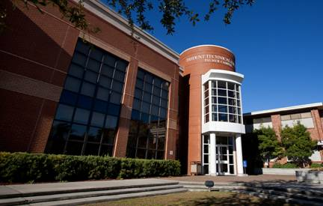
THEN NOW
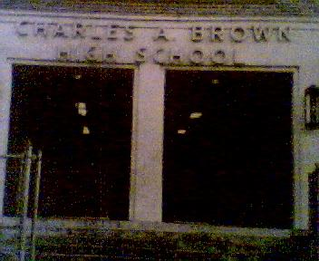
On October 25, 2012, The Preservation Society of Charleston will honor C. A. Brown High by placing a Historical Marker at Trident Technical College Palmer Campus, the site that once housed our beloved school. This prestigious honor was the result of alumni, family and friends voting overwhelming for our Alma Mater to be recognized as having historical and meaningful impact on the community.
In conjunction with Trident Technical College “Eastside Day” and the celebration of C. A. Brown High School 50th anniversary, the Historical Marker will be unveiled. To commemorate this worthy achievement, CABHAA is inviting you to become a permanent part of history by purchasing bricks with your inscription to be prominently displayed around the marker. The 4 x8 brick allows a maximum of three lines, each line containing up to 14 characters including spaces and punctuation. The cost is $ 30.00 per brick. The deadline for submission is September 1, 2012. We will not accept personal checks after August 25, 2012.

Memorials

Mrs. Rosa Mae Davis, mother of Gwendolyn Fraiser (70), home-going services was held on Thursday, February 23, 2012 at Jerusalem Missionary Baptist Church in Charleston, S. C.

Shirley Ann Duffy home-going services was held Tuesday, March 6, 2012 at Royal Missionary Baptist Church in Charleston, S. C.

Sandra L. Foster (66) funeral services was held Wednesday, May 30, 2012 at Mount Caramel UM Church in Charleston, S. C.

Mrs. Lucille Grant, mother of the late Bruce Grant (70), was memorialized on Saturday,
March 10, 2012 at Emanuel AME Church in Charleston, S. C.

Shirley Grant (68) home going services was held on Saturday February 25, 2012 at St. Paul AME Church in Georgetown, S. C.

Robert Nelson (81) home-going services was held April 2012 in Charleston, S. C.

Thomas “Tommy” Rivers (69) funeral services was held at Jerusalem Missionary Baptist Church on Tuesday, June 27, 2012 in Charleston, S. C.

Monte Robinson (71), brother of Leander Waring (67), was memorialized on Thursday, June 14, 2012 at Emanuel AME Church in Charleston, S. C.

Mrs. Betty Maddox, mother-in-law of Jimmy Kirkland (71), funeral services was held on Wednesday, June 13, 2012 in Charleston, S. C.

Issaic “Duck” Montgomery, husband of Marva Montgomery (71), funeral services was held on Wednesday March 27, 2012 at Jerusalem Baptist Church in Charleston, S. C.

Publication of the Association Newsletter is done twice a year, in July & December

Alumni Officers

Joseph T. Washington (Joey), President (80)
joswashsr@aol.com

Sharon Coakley, Vice-President/Public Relations (70)
sharon.coakley@kapstonepaper.com

Karyn Hart, Secretary (79)
specialkk810@yahoo.com

Joleitha Solomon, Assistant Secretary (80)
solomojo@musc.edu

Virgie Bryant-Green, Treasurer (71)
virgiebryantgreen@yahoo.com

Richard Gathers, Assist. Treasurer (66)
rgatherssr@yahoo.com

Ruth G .Coleman, BMC Chairperson (72)
ruthiegrant@knology.net

Vanessa Goodwin, BMC (75)
candy6@bellsouth.net

Mozetta Clark, BMC (82)
mnclark1@comcast.net

Nathaniel McKnight, BMC (67)
mckval@bellsouth.net

Robert Crawford, Sr. Chaplin (71)
Chipco71@aol.com
_____________________________________________________

Got An Idea?

Send us your ideas, suggestions, birthdays, anniversaries, or items of interest so that we can include them in the upcoming Newsletter.

P. O. Box 532
Ladson, S. C. 29456
(843) 437-0183

For all your future events contact Crawford Photos; “We tell the story through photos, weddings, special occasions & individual artwork-framing and matting”. Call 843-875-3277.
___________________________________________________________________________________

Prayer Line
Our prayers are with our president Joey Washington as he continues to recover from surgery.

Let’s remember to keep all of our classmates and their families in prayer.

